UTCTF 2023

A Network Problem - Part 2

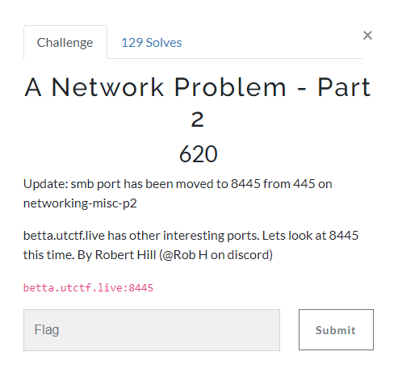

note : I had to use my web server because the schools wifi was blocking me from using smb

1. Scanned with nmap



1. From the question and t he nmap scan we learn that port 8445 is a smb port
2. After looking up we learn SMB is The Server Message Block (SMB) Protocol is a network file sharing protocol by microsoft
3. On kali linux we can use smbclient to interact with smb protocol
4. Use smbclient -L <ip> to view shares

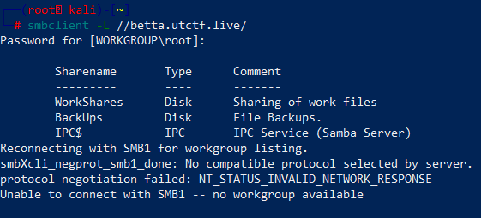

1. Now that we have share names we can directly access them with smb client the commanded is smbclient //<ip>/<share>

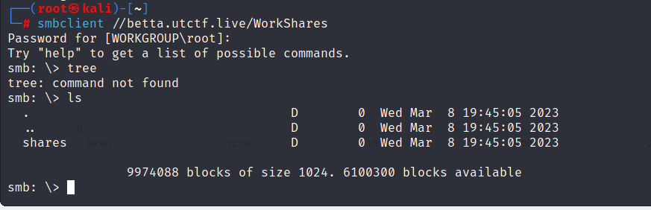

1. Once in us ls to list dir and files
2. Use cd <dir> and ls to navigate share and find the different files

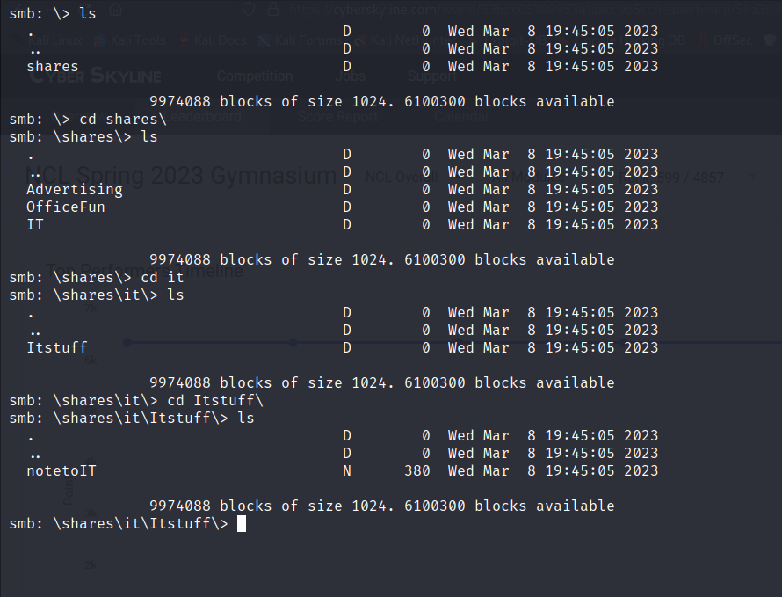

1. The file we are looking for is notetoIT, to get it back to our local machine we use the get commanded get <file>

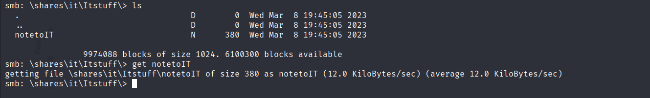

1. Once we have the file we can leave share, use cat commanded to view it





We got the flag and a hint too the next question